
Released Dec 15th
Hello Team Officials,
Welcome to the 40th Annual New Year’s Classic being hosted by the Scarborough Sharks GHA. Thank you for taking the time to come and celebrate a weekend of outstanding female hockey. We are grateful to see our returning teams who have over the past many years come from near and far to engage ours and other association teams in fair play, strong competition, and as always, friendships that know no borders in a true testament of our collective love of our game.

We are truly excited to announce that we have reached 125 Teams. Thank you for your support!

At this time of the year, may I on behalf of the Scarborough Sharks GHA Executive team and members, wish everyone the happiest of holidays, Merry Christmas, and all the best in the 2026 New Year.

Shirley Collins
President, Scarborough Sharks GHA

Tournament Information
- Tournament Headquarters: Canlan Ice Sports Scarborough – Upstairs in Restaurant
- 2026 Tournament Schedule: Now available in the Documents Section of the main event page.
- Official Website: https://www2.sportacularevent.com/portal//events/event/118

- RULE#1 - All Teams will Register at your first game by producing your Official OWHA Approved Roster to the Convenor onsite. Hockey Canada and OWHA SUSPENSION rules shall apply where required. Any team using an OWHA Pickup Players must follow these rules of face Forfeiture and or Suspensions and fines. Teams may use the MAX 3 of 3 Players to Replace Existing players on their Official Roster. You can NOT Replace Suspended players. Rep teams may only use Players from BELOW LEVEL OF PLAY – No Lateral Callups even if playing up in a combined division. HL Teams are allowed to use lateral pickup players. Please note at no time can you NOT exceed the total # of players on your official Roster. The use of an official OWHA Pickup can only be accessed inside your teams RAMP acct, we are no longer are allowed to accept paper versions.

- If you find what you believe as an incorrect score, please notify us via email @ info@sportacularevents.com to help expedite inquiries. Please in subject line use: Game Concern - the division and GM# - then share your concern. Saturday is a very busy day for advancing teams. We have a process which identifies which divisions have to be advanced in a chronological process. Many inquiries are made and the pool or divisions has not completed their final RR games in order for us to calculate and advance teams. We appreciate everyone’s patience.
- Team Ramp Game Codes will be made available once everything is uploaded. The OWHA is still populating divisions in the Tournament link, so please remain patient as teams receive their Final Roster Approvals.

Team Roster Submission
- Official PDF Rosters MUST be uploaded to your Sportacular Events account.
- All out of province teams must provide their travel permits 10 days before
- Mandatory request for all teams - Log in to your Sportacular Event Acct, go to MY TEAMS, select your registered team, and click EDIT to update your roster and bench staff to ensure correct contact information is correct. Players only require jersey# and name.
- Yes, it needs to be manually typed in for the information below
- Be sure to save your updates to ensure accuracy for game sheets
- A single-page game sheet system is used for consistency between ice-level officials and administration.
- You may now also, as shown where to Upload your team’s official PDF roster.

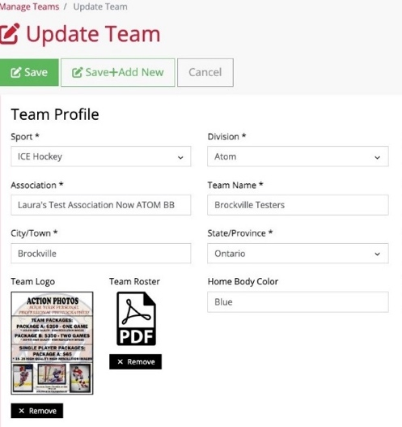
2025 Tournament Updates
- "Player of the Game" awards will be given for every game pickup at Arena Convenor Table in lobby you will sign for the award.
- Special Finals Player of the Game award is a commemorate gold medal
- Championship Finals: Winners receive Gold Medals and an Arena Banner; finalists receive Silver Medals.
- New Awards: Same as Player of game awards, if a player has a Hat Trick or Shutout
  - "Wholly Moly Who's That Goalie" Shutout Awards
  - "Holy Hat Trick" Awards for players scoring a hat trick

Important Rules & Reminders
- Player Eligibility: Players can only compete with one team in one tournament during the weekend
- Pickup Players: Any team using an OWHA Pickup Players must follow these rules or face Forfeiture and or Suspensions and fines.
- Any team Found to be using an illegal player or playing suspended players will be removed from the tournament and any further games will results in Game Forfeitures. The OWHA Will also be notified as required
- Rep Teams: Allowed max 3 replacements but cannot replace suspended players. Rep teams may only use Players from below levels of play – No Lateral Callups even if playing up in a combined division. If a team has been found to use an illegal callup or player the team will be removed from the event
ALL Teams cannot exceed their official roster limit at any time.

- Equipment Rules:
- USA Teams: Mandatory mouthguards (per USA Hockey Insurance).
- Canadian Teams: Mandatory BNQ neck guards (per Hockey Canada)
- Suspensions: Hockey Canada and OWHA SUSPENSION rules shall apply where required. All suspensions must be reported to OWHA via email and await their direction as to number of games. You must comply. Clearance must be received before returning to play. Teams from out of Province will be notified of IF a member of team is under suspension
- Travel Permits: All out-of-province teams must submit their travel permits and email to Sportacular Events. If Travel permit is not provided the team is not allowed to play it’s a Hockey Canada Insurance Rule
- Rosters: Have a copy of your roster available in the event of any discrepancy
- Tournament Rules: Posted live on the Sportacular site. Please also note we do not use GF/GA we instead use the Tie Breaker Calculator chart in the document sections.
- Home and Away Jersey Colors Sect 17 of OWHA Handbook
- Home Teams will wear Dark colored Jerseys and visitor teams will wear light.
- NOTE: for the 2025/26 Season Home teams have the Option to wear Light Colored Jerseys.
- If they choose to wear Light Colored as Home Team, they must notify visiting team once games are scheduled. We recommend to approach the other team when at the arena.

Game Day Procedures
- Jersey Color Conflicts: Teams should bring an extra set of jerseys or pinnies to avoid conflicts.
- Championship Awards & Photos: Arena banners and medals will be awarded off the ice due to safety and City and Town insurance regulations
- Dressing Rooms:
  - Bring your own lock where required.
  - Keep rooms clean before vacating.
- Game Start Times: Games may begin up to 20 minutes early based on arena convenor coordination
- Check-in Requirements: Team managers or head coaches should check in with arena convenor in lobby before each game. You do not need to check in a headquarters.
- Player of the Game Award: A player of the game DOG TAG will be provided at the sign in table prior to the start of each game and awarded by the coach who will sign for the item
- Shutout/Hatrick Awards: Available at the convenor table at the end of your game

- Identifying Event Staff: Sportacular Event Staff will wear red jackets with “Event Staff on the bank. Ask for help at any game sheet sign-in area
- RAMP Game Codes: Will be emailed and also available at game sheet convenor tables.

Final Notes
- 2026 Tournament Rules now live.
- If we promised thank-you or incentives items, please remind us before the first game so we have them ready for you.

We look forward to seeing you all in soon to officially Kickoff the 2nd half of the season!
Check the event main page for ongoing updates. https://www2.sportacularevent.com/portal//events/event/118
Thank you, and best of luck to all teams!
Tournament Vendors
- Northwest Clothing Official Clothier – Setup Canlan and Malvern Arena
- Busy Beads Croc Charms – Malvern
- Lily the Unique and special Toy Lady – Canlan Scarborough

Live Barn should be live at arenas that have this capability.
Skate Sharpening Info:
Canlan Scarborough Pro-shop is open all weekend


  - 2026 Scarborough Sharks
  - Tournament Rules

OWHA Sanction # 2526026
- All Teams will Register at your first game by producing your Official OWHA Approved Roster to the Convenor onsite. Hockey Canada and OWHA SUSPENSION rules shall apply where required. Any team using an OWHA Pickup Players must follow these rules of face Forfeiture and or Suspensions and fines. Teams may use the MAX 3 of 3 Players to Replace Existing players on their Official Roster. You can NOT Replace Suspended players. Rep teams may only use Players from BELOW LEVEL OF PLAY – No Lateral Callups even if playing up in a combined division. HL Teams are allowed to use lateral pickup players. Please note at no time can you NOT exceed the total # of players on your official Roster. The use of an official OWHA Pickup can only be accessed inside your teams RAMP acct, we are no longer are allowed to accept paper versions.
- All games will consist of 3 periods (10 minute-10 minute-12 minutes), stop time with the exception of, U15A, U18A, U18BB, U22A/SRA will consist of 3 periods of (12minute–15 minute-15 minute), stop time. LONGER GAMES will have floods that will take place between 2nd & 3rd periods for single games and flood every 2 periods for back-to-back longer games. Ask arena convenor at game sheet sign in table in each arena
- There will be a 3minute warm-up prior to each game for ALL DIVISIONS.
- All teams MUST be available to play UP TO 20 minutes prior to the scheduled start time at the discretion of the arena convenor.
- The OWHA minimum suspension guidelines will be strictly enforced. All suspensions will be enforced according to OWHA Constitution, By-laws, and Regulations & Rules.
- Girls will tap gloves after each game.
- If the goal spread at any time of the “Third period reaches 5 goals”, the clock will RUN until the spread is reduced to 3 goals, then stop time will resume.
- One - 30 second timeout will be allowed for each team ONLY during Consolation, Elimination - Quarter - Semifinal & Championship games only. Overtime is not a new game. There is NO TIMEOUT in Round Robin Games.
- A maximum 18 skaters and 2 goaltenders may be registered with each team. You cannot exceed your total number of players showing on your official roster.
- A player may only participate with one designated team in a tournament and may only participate in one tournament on any date.
- To be eligible to participate in the tournament, the participant’s name must appear on the team roster form submitted with the entry form. Changes to the roster must be made in writing and will not be permitted after registration prior to the team’s first game. Players on Ontario teams must be registered with the OWHA. The OWHA “Pickup Consent” forms will be honored and must be included where necessary based on OWHA Rules.
- Teams will be awarded 2 points for a win, 1 point for a tie and zero (0) points for a loss.
- Standings after the round robin will be calculated on the basis of the points awarded as per rule # 12.
In the event of a tie, the following criteria will be used to break the tie:
- Winner between the tied teams when they played head-to-head. (Applies to 2 Way ties only, 3 or more teams tied start with Tie breaker 13B)
- Percentage as calculated by dividing team’s total “Goals For” by the SUM of the team’s “Goals for and Goals Against”. TGF / (GF+GA) = % (See Tie Breaker Ratio Chart)
- Fewest Goals Against.
- Most Goals For.
- Fewest Penalty Minutes.
- Coin Toss.
- Follow Tie breaking rules in Order. Once a Tie Breaking Rule has been used or is not applicable it cannot be used again.
- IF a team(s) remove prior to the event (up to 72 hrs. before) every opportunity will be made to find a replacement team. If, however a team cannot be found where One or BOTH teams are unable to ice a team, or facilities breakdown / malfunction or game cancellation due to inclement weather, COVID and PHU or Provincials orders prevent teams from attending we will unfortunately NOT be able to reschedule the game. If unable to reschedule the game(s) will be considered as an Official OWHA Forfeiture score. It will be recorded as either 5-0 for a “single team no show” or if both teams are unable the score will be recorded as a Hockey Canada Forfeiture of a 0-0 tie for both teams to assist in determining rankings to find a divisional winner as required in conjunction with tie breaking rules. Tournament organizers and committees are not liable or responsible for acts of God and unforeseen events mechanical breakdowns, causing the cancellation of any part of whole if this event. ONLY 1 team official will sign the game sheet prior to each game
- In 4 and 10 Team Divisions: After round robin the teams will be ranked 1st – 4th and advance to their perspective Semi Final Games with winners to finals.
- In 6 Team Divisions: 1st & 2nd Overall advances to the Semi finals while, 3rd through 6th overall will play an elimination game with the winners advancing to the Semi finals.
- In 8 Team Divisions: 2 pools of 4 teams: After round robin play the teams in each pool will be ranked and advance to their perspective Quarter final with the winners advancing to the Semifinals.
- In 6 Team U11B Division: After round robin play the B and C teams will be ranked 1st through 3rd. The 1st Place B Team will advance to the B Championship Final while the 2nd and 3rd Place B teams will play an elimination game to see who advances to the B Championship Final. The 1st Place C Team will advance to the C Championship Final while the 2nd and 3rd Place C teams will play an elimination game to see who advances to the C Championship Final.
- In the 10 Team U18B Division: After round robin play the B teams will be ranked with 1st through 4th advancing to the B semi finals and the C teams ranked 1st and 2nd playing in the U18C Championship.
- In the 12 Team U11DS Division: After round robin play the teams will be ranked with 1st through 4th teams in each pool advancing to the Quarter Finals while the 5th and 6th place teams in each division will play a Consolation game.
- Elimination – Quarter - Semi-Finals - & Championship games are played to a winner. In the event of a tie at the end of regulation time a Sudden Victory 5minute overtime will commence. Teams will play 4 on 4 PLUS Goalies. (See format for rules) Players may be changed at any time. Goalies may be “pulled” at any time and a substitute player from the bench may be used. If still tied, a shoot out will occur.
- Shoot Outs: Teams do not change ends for Overtime or Shoot Outs.
Each team must designate 3 shooters (S1, S2, S3) directly onto the game sheet prior to the start of the game.
Any player serving a penalty at the end of overtime will not be eligible to participate in the shoot out and MUST remain in the penalty box. All players except shooter and goalies will be on the bench. Once a player has shot, they will go to the penalty box. Shooters from both teams will shoot simultaneously, starting at centre ice.
This is a BEST OF 3 Shootout. If still tied, each team will designate one shooter at a time until there is a winner.
A player may not shoot for a second time until all players on the game sheet (except goalies) have shot.
- Home and Away Jersey Colors Sect 17 of OWHA Handbook; Home Teams will wear Dark colored Jerseys and visitor teams will wear light. NOTE: for the 2025/26 Season Home teams have the Option to wear Light Colored Jerseys. If they choose to wear Light Colored as Home Team, they must notify visiting team once games are scheduled. We recommend to approach the other team when at the arena.
- Where needed only 1 team official will sign for POG awards prior to each game.
- Flooding of the ice will occur at the end of each game or as required and may be deferred at the Tournament Committee’s discretion.
- It is the team’s responsibility to ensure a clean dressing room is left upon completion of their game. All teams are requested to vacate the dressing room 30 minutes or less after their game is completed
- The decisions of the Tournament Officials are final with no appeals!
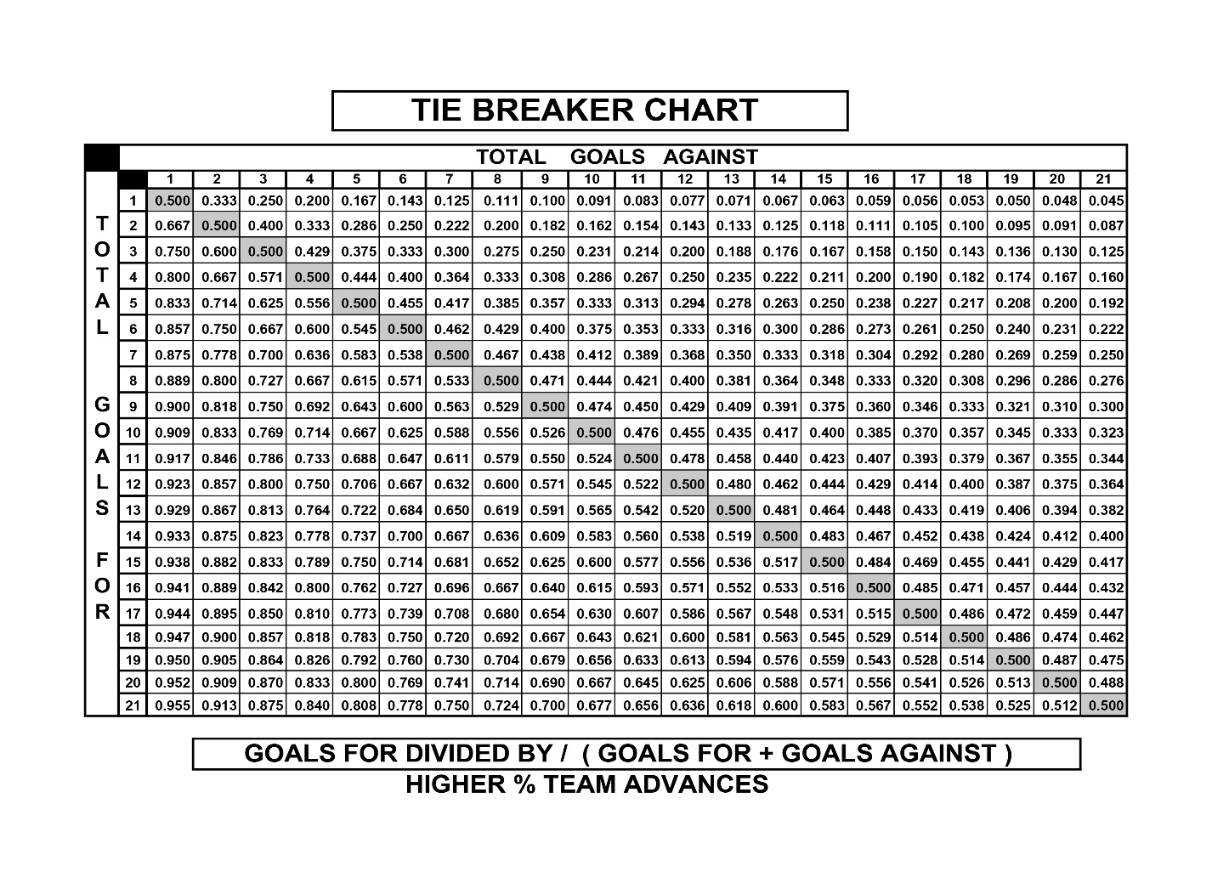

**WE RESPECTFULLY ASK FOR YOUR ASSISTANCE IN THAT NO TEAM PHOTOS
BE TAKEN ON ICE DUE TO Municipality & City Insurance Regulations.
*Championship Awards and Medals / Banners
WILL be Presented Off- Ice and will be distributed by coaches as required.
Reminder ALL Suspended Athletes and Bench Staff may not participate in medal presentation ceremonies as per OWHA Rules. We thank you for your anticipated support in this matter.

  - 2026 Scarborough Sharks
  - OVERTIME RULES FOR
Elimination, Quarter-final,
Semi-final, and Championship Games

OWHA Sanction # 2526026

- Elimination, Quarter-final, Semi-final, Consolation and Championship games are played to a winner.
- In the event of a tie at the end of regulation time a SUDDEN VICTORY FIVE (5) MINUTE OVERTIME will commence.
- Overtime will be played 4-on-4, plus goalies
  - Any penalties being served at the end of regulation time will carry over to the overtime period.
  - Example 1: If a team is one player short, then overtime will start 4-on-3.
  - Example 2: If a team is 2 players short, they OT will start 5-on-3. On ice strength will be adjusted back to 4-on-4, as per OT rules, at stoppages of play after the penalties expire.
- Clarifications:
  - If a penalty is assessed to one team during the overtime period, play shall resume 4-on-3
  - Should a second penalty be assessed to the same team, play will resume 5-on-3 until the expiry of the first penalty.
  - If the penalty expires during play, the player shall return to the ice and teams will play 5-on-4 until the next stoppage of play, at which point the on-ice strength will be adjusted to 4-on-3, etc.
  - At no time will a team have fewer than 3 skaters (plus goalie) on the ice
- Teams will play 4 on 4 plus goalies. Players may be changed at any time. Goalies may be “pulled” at any time and a substitute player from the bench may be used.
- Penalties do NOT expire at the end of regulation time.
- If still tied, a shoot out will occur.
- Each team MUST designate 3 shooters (S1, S2, S3) on the game sheet BEFORE the start of the game.
- Any player(s) serving a penalty at the end of overtime will not be eligible to participate in the shoot out and MUST remain in the penalty box. The coach must designate a shooter(s) to take her place(s) immediately at the end of regulation time.
- All players except shooter and goalies will be on the bench TO START.
- Shooters from both teams will shoot at the same time starting at the centre ice red line.
- Once a player has shot, they will go directly to the penalty box.
- This is a BEST OF 3 Shootout.
- If still tied, each team will designate one shooter at a time until there is a winner.
- A player may not shoot for a second time until all players on the game sheet signed (except goalies) have shot.
- A penalty assessed in regular time will carry forward to the overtime period. Therefore, the player will not come out of the box.
**WE RESPECTFULLY ASK FOR YOUR ASSISTANCE IN THAT NO TEAM PHOTOS
BE TAKEN ON ICE DUE TO Municipality & City Insurance Regulations.
*Championship Awards and Medals / Banners
WILL be Presented Off- Ice and will be distributed by coaching as required.
Reminder ALL Suspended Athletes and Bench Staff may not participate in medal presentation ceremonies as per OWHA Rules. We thank you for your anticipated support in this matter.

